**Database Normal Forms**

First Normal Form:

* Each table cell should contain a single value.
* Each record needs to be unique.

Example:

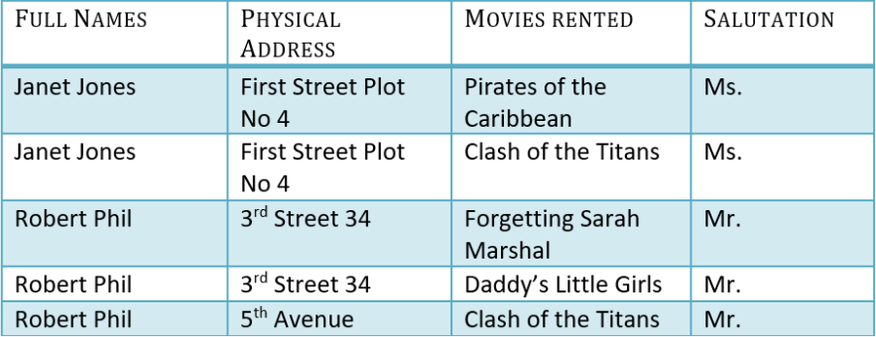

Second Normal Form:

* Be in First Normal Form
* Single column primary key that does not functionally dependent on any subset of candidate key relation

Example:

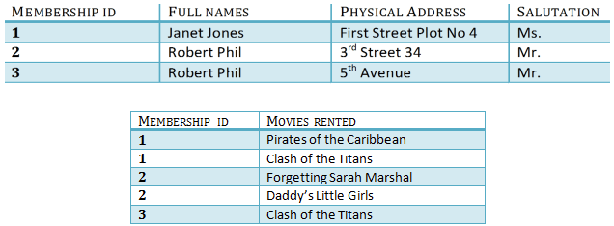

Third Normal Form:

This time you divide the tables again and the table which stores Salutations.

There are no transitive functional dependencies, and hence the table is third normal form.

In Table 3 Salutation ID is primary key, and in Table 1 Salutation ID is foreign to primary key in Table 3

Example:

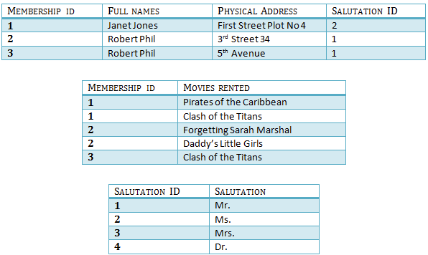

Boyce-Codd Normal Form:

Even when a database is in 3rd Normal Form, still there would be anomalies resulted if it has more than one Candidate Key.

Sometimes BCNF is also referred to as 3.5 Normal Form.

Fourth Normal Form:

If no database table instance contains two or more, independent and multivalued data describing the relevant entity, then it is 4th Normal From